# CS 255 System Design Document Template

This template lays out all the different sections that you need to complete for Project Two. Each section has guidance to prompt your thinking. You will need to continually reference the interview transcript as you work to make sure that you are addressing your client’s needs. There is no required length for the final document. Instead the goal is to complete each section based on what your client’s needs are. Remove this note when you are finished, and replace all bracketed text with the relevant information.

## UML Diagrams

### UML Use Case Diagram

### UML Activity Diagrams

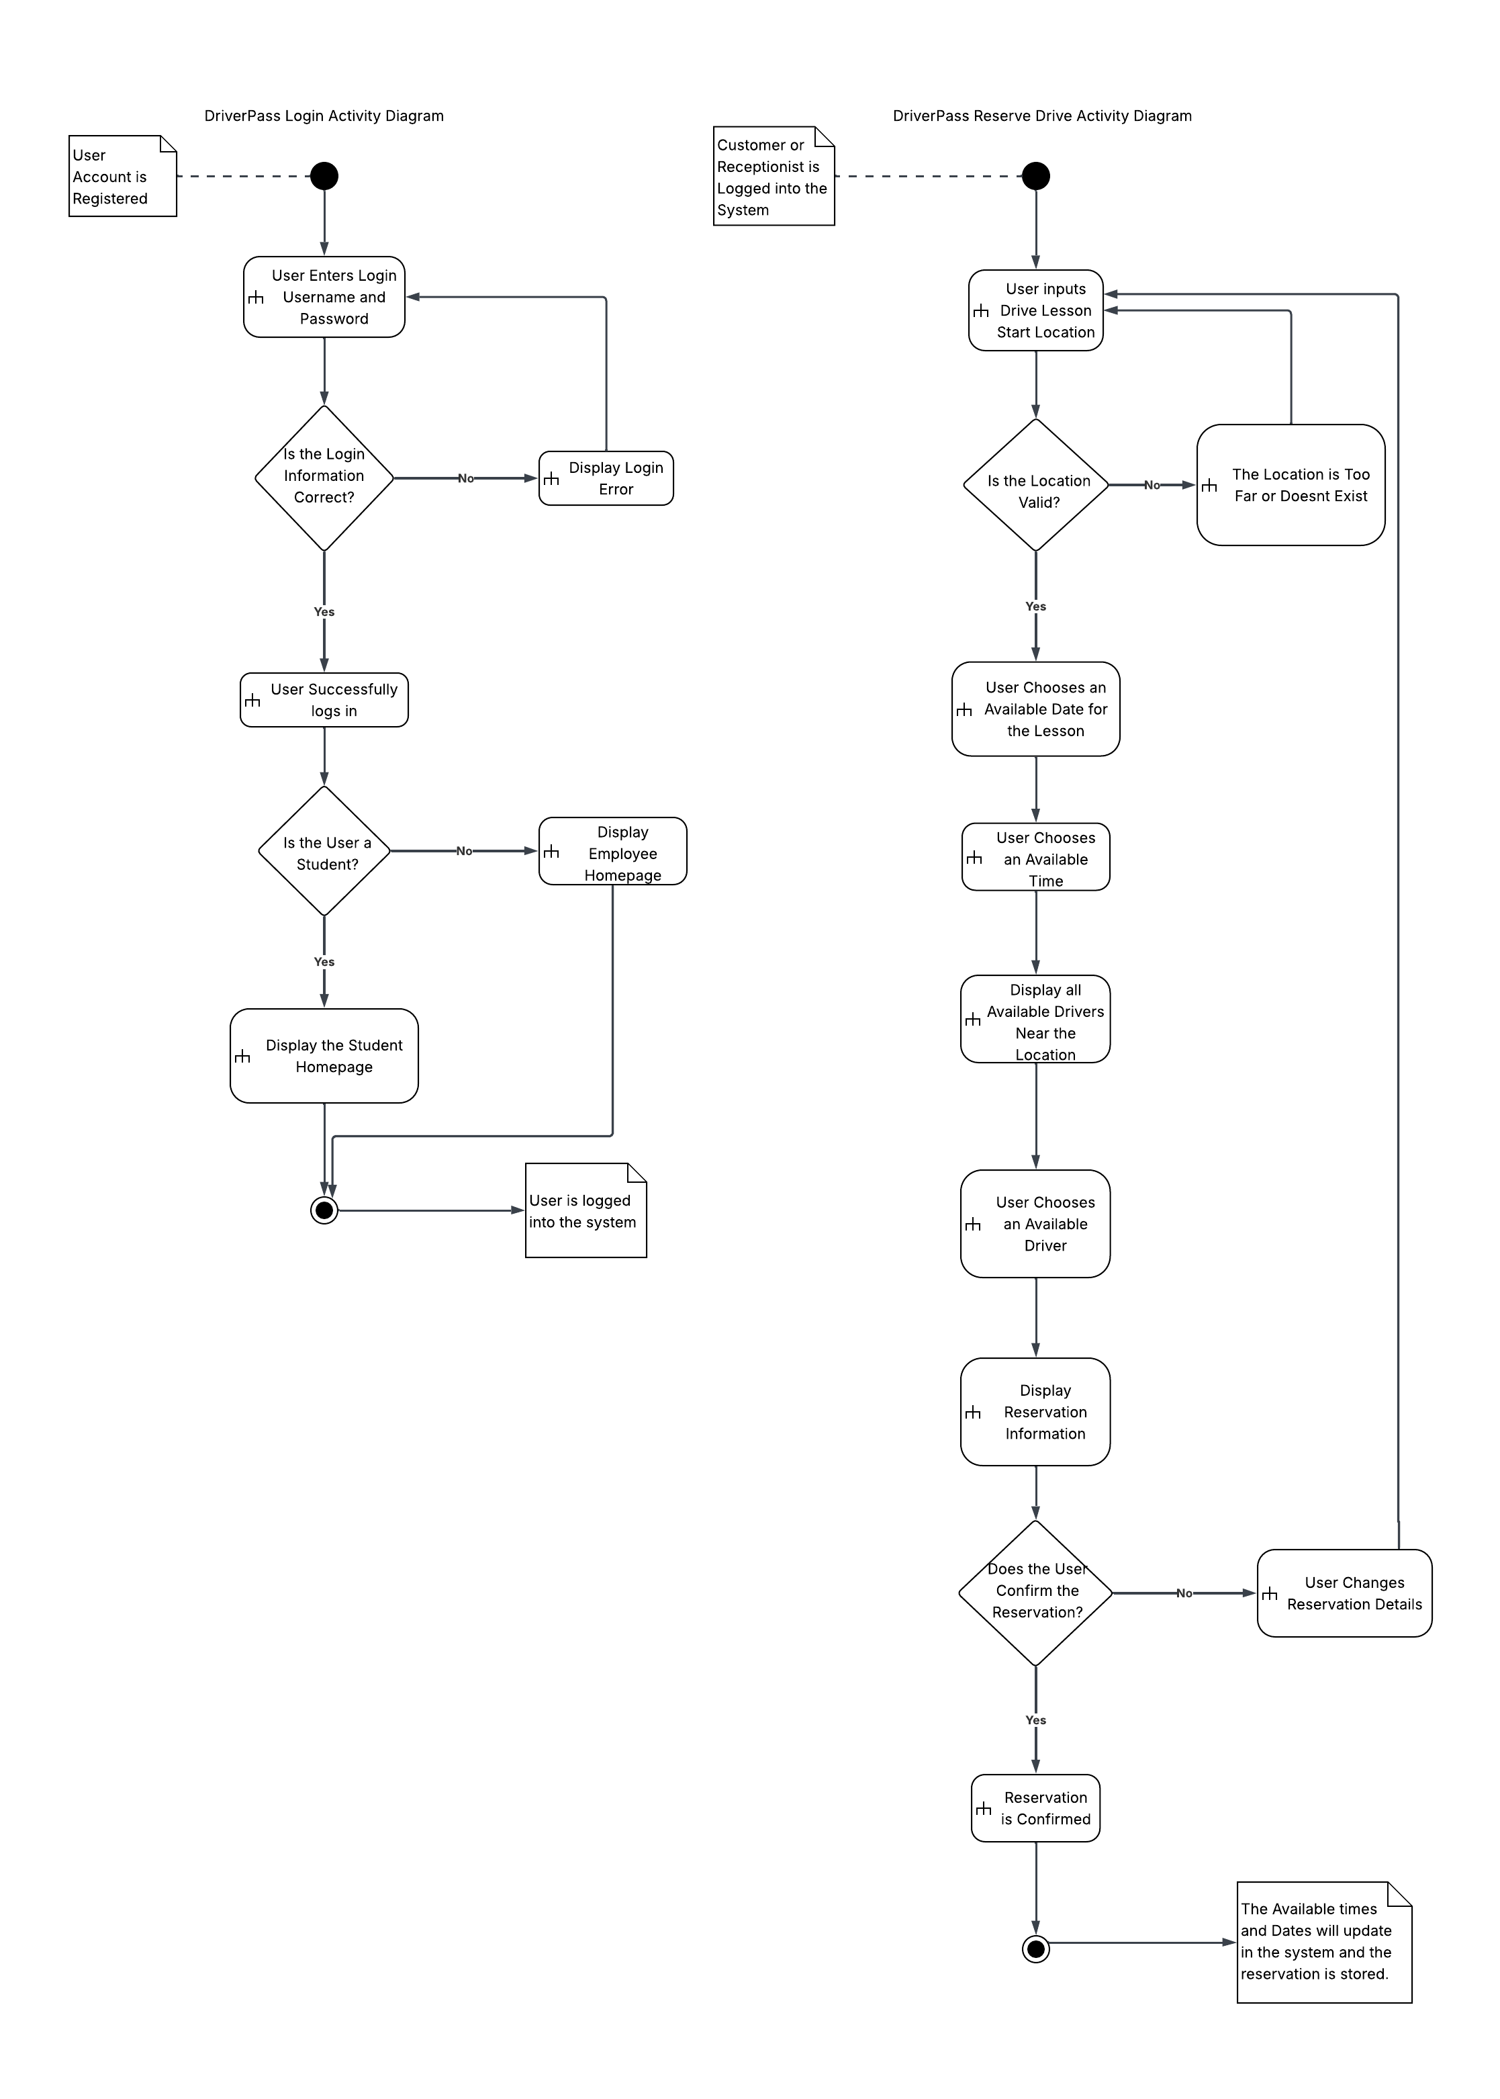

### UML Sequence Diagram

### UML Class Diagram

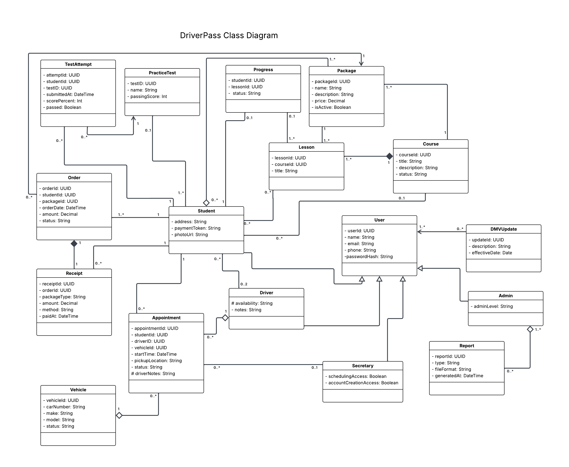

## Technical Requirements

The DriverPass system will be a web-based program that can be opened on any internet browser on a computer or phone. The website will use standard languages like HTML, CSS, and JavaScript to build the pages and make them easy to use on different devices. The main system that handles logins, schedules, and test results will be built using a common programming language such as Python or Java, and the data will be stored in a database like MySQL. The database will keep track of users, lessons, packages, appointments, and payments. Each type of user will have different access levels based on their role to help keep data secure.

DriverPass will be hosted online using a cloud service so users can access it anytime without needing to install software. The cloud also helps the system back up data, provide security, and handle many users at once. It will also make it easier for the IT officer to maintain the system and manage updates without needing physical servers. The system will connect to other online tools, such as payment processors and DMV update services. As long as users have internet access and a modern browser, they’ll be able to log in, take practice tests, schedule lessons, and view their progress through the system.